**Execution**

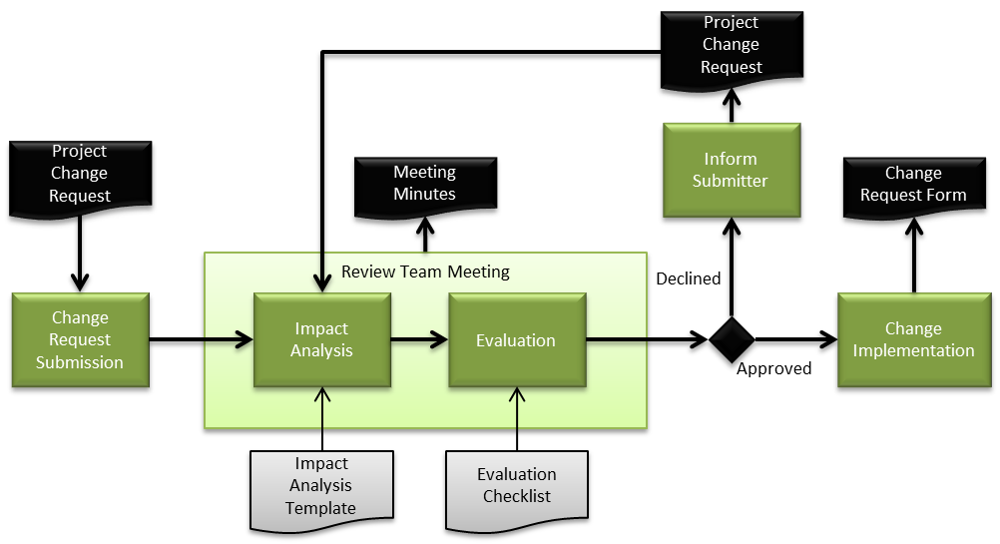

When the Requirements List is agreed upon and signed and placed under Configuration Management all changes to this list shall be formally requested and documented with the Project Change Request (PCR).

A Project Change Request may be submitted by any of the identified stakeholders.

The Project Manager shall invite involved project team members and if required other key personnel within T-engineering to a Review Team Meeting.

The purpose of this meeting is to do an impact analysis and evaluation of the requested change to be able to make a united decision on whether to approve or decline the Change Request and if it affects the Time plan or cost of the project.

The Meeting Minutes from this meeting serves as documentation of evaluation and analysis and will be archived in the REQM folder under the Project folder in Google Drive.

The Project Manager is responsible for informing the one who submitted the request of the result of Review Team Meeting, including time and cost estimates.